**Class Variables**

Class variables are common for all instances of the class while, instance variables are unique for that particular instance.

A good example in our case could be the raise of salary given to every instance (employee) in the class. The following case illustrates this:

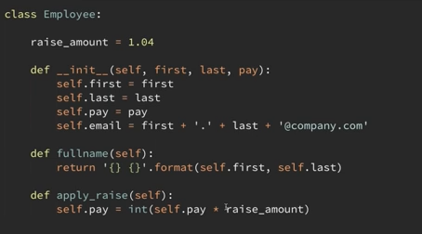

But upon execution of the following:



It throws an error saying that raise_amount is not defined. This is because we are calling the method directly without any reference to the class or the instance. Hence methods must be accessed theough the class itself or an instance of the class.

One way is to use the class variable:



Or can be accessed using the instance itself:



When you print the dictionary values of any single instance of the class:



You get the following:



The raise_amount is not printed.

But when access through the class itself:



It is printed below:



Consider the following two scenarios:



And: (here using self allows us to override the value assigned to the class)

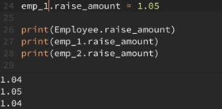

Now for instance emp_1:



We get the following:



What if you want to increment the number of employees created after each creation? We can create a class variable called num_of_emps for that purpose:

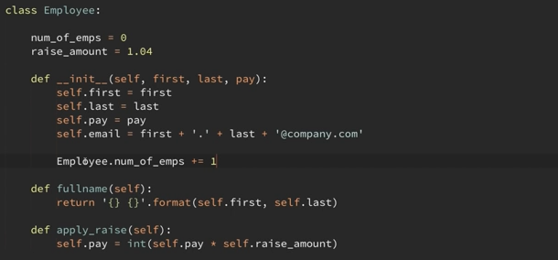

So the following snippet:



It would display 2, because it was instantiated to 2 for two employees created.